EAAP: Enterprise AI Architecture Pattern
A Governance Architecture for Deterministic Enterprise AI Systems
John Goulden
research@johngoulden.de
Independent Researcher, Germany
ORCID: 0009-0000-5626-6535
May 2026
Version: v1.0

Abstract
Enterprise adoption of artificial intelligence has accelerated faster than the development of corresponding governance architecture. While large language models and multi-agent systems demonstrate increasingly capable reasoning behaviour, most enterprise deployments remain architecturally incomplete: governance is frequently implemented as policy rather than structural control, evidence provenance is often absent, confidence is rarely calibrated in operationally meaningful ways, and AI systems are commonly integrated directly into operational environments without execution boundaries.
This paper presents the Enterprise AI Architecture Pattern (EAAP), a governance-oriented architectural model for enterprise AI systems operating in high-trust and high-impact environments. EAAP defines a layered orchestration and governance framework intended to constrain, structure, and audit AI-assisted operational reasoning. The framework introduces governance-deterministic orchestration principles, domain-isolated reasoning agents, evidence classification models, calibrated confidence gates, human approval boundaries, and execution isolation through controlled automation gateways.
Unlike model-centric approaches that treat the underlying large language model as the system itself, EAAP positions the model as a replaceable reasoning component operating within a larger governed architecture. The framework is designed to support air-gapped and sovereign AI deployments, including enterprise environments where external API connectivity is prohibited or operationally unacceptable.
This paper defines the architectural principles, threat model, orchestration model, governance layers, and operational constraints of EAAP, presents an illustrative operational scenario, and identifies the current limitations and future research directions of the framework.

Keywords: enterprise AI governance, orchestration, governance determinism, sovereign AI, multi-agent systems, evidence classification, auditability, AI architecture, air-gapped AI, threat model, operational governance

Table of Contents
Abstract 1
1. Introduction 4
1.1 Problem Statement 4
1.2 Authorship and Intent 4
1.3 Research Contributions 4
2. Background and Related Work 5
2.1 Enterprise AI Adoption 5
2.2 Existing AI Governance Approaches 5
2.3 Multi-Agent Systems and Orchestration Frameworks 6
2.4 AI Safety and Human Oversight 6
2.5 The Governance Gap 6
2.6 Architectural Differentiation 7
3. The Architectural Problem 7
3.1 Terminology: Governance Determinism 8
4. Threat Model and Failure Modes 8
4.1 Overview 8
4.2 Threat Interdependencies 10
5. EAAP Core Principles 10
6. EAAP Architecture Overview 11
6.1 The Layered Model 11
6.2 Domain Isolation 12
6.3 Governance-Deterministic Orchestration 12
7. The Governance Layer 12
7.1 Evidence Classification 12
7.2 Confidence and Uncertainty 13
7.3 Human Approval Boundaries 13
8. The Orchestration Layer 13
8.1 Supervisory Coordination 13
8.2 Conflict Resolution 14
8.3 Conditional Override Logic 14
9. The Domain Intelligence Layer 14
10. The Execution Layer 14
10.1 Automation Gateway Model 14
10.2 Plan-Approve-Execute Workflow 15
11. Air-Gapped and Sovereign Deployment 15
12. Auditability and Traceability 16
13. Illustrative Scenario 16
13.1 Scenario Overview 16
13.2 Governance Lifecycle Trace 16
13.3 Scenario Observations 17
14. What EAAP Cannot Do and Non-Goals 18
14.1 What EAAP Cannot Do 18
14.2 Non-Goals 18
15. Governing Rules 19
16. Current Limitations 19
17. Future Research Directions 20
18. Conclusion 20
Appendix A: Terminology 21
References 22
Acknowledgements 22

Figure 1 - EAAP layered architecture model. 11
Figure 2 - EAAP orchestration lifecycle. 12
Figure 3 -EAAP Plan-Approve-Execute-Audit workflow. 15

1. Introduction

1.1 Problem Statement
Enterprise deployment of artificial intelligence has accelerated rapidly across infrastructure operations, software engineering, cybersecurity, customer support, compliance analysis, and enterprise knowledge management. However, the governance architecture surrounding these deployments has not matured at the same rate.
Most current enterprise AI implementations exhibit one or more recurring structural weaknesses:
- AI recommendations are generated without evidence provenance.
- Confidence levels are either absent or operationally meaningless.
- Human approval processes are advisory rather than structurally enforced.
- AI systems are granted direct operational access to infrastructure.
- Multi-domain reasoning occurs without orchestration or arbitration.
- Governance controls are implemented as organisational policy rather than architectural constraint.

These weaknesses create a governance gap between AI capability and operational trustworthiness. The problem is not primarily model intelligence. Increasing model capability alone does not resolve the absence of auditability, controlled execution, operational traceability, or governance enforcement. This paper argues that enterprise AI requires governance architecture, not merely more capable models.
The Enterprise AI Architecture Pattern (EAAP) is proposed as a governance-oriented architectural framework intended to constrain and structure AI-assisted operational reasoning in enterprise environments. EAAP is not a model, product, or software platform. It is an architectural control pattern.
EAAP is a conceptual governance architecture and not a certification framework.

1.2 Authorship and Intent
This paper presents a governance-oriented enterprise AI architecture framework intended to increase operational safety, auditability, and governance enforcement in enterprise AI systems. The framework constrains AI behaviour through structural mechanisms rather than relying solely on organisational policy or operator discretion.
Nothing in this paper should be interpreted as advocating autonomous operational decision-making without human oversight. The framework is explicitly designed around the principle that AI systems provide structured recommendations while accountability and operational authority remain human responsibilities.

1.3 Research Contributions
This paper makes the following specific contributions:
- A governance-oriented layered architecture pattern for enterprise AI systems operating in high-trust environments, positioning the large language model as a replaceable reasoning component.
- A formal definition of governance determinism as a new architectural concept distinct from computational determinism.
- A threat model identifying nine failure modes that governance-oriented AI architecture must address.
- A formal evidence classification model requiring AI outputs to disclose the provenance and basis of all recommendations.
- A tiered human approval boundary model that structurally enforces human oversight for high-impact operations.
- An execution isolation model prohibiting direct AI access to operational infrastructure through a controlled Automation Gateway.
- A Conditional Override mechanism that replaces false certainty with escalation when confidence or evidence is insufficient.
- An architectural model explicitly designed to support air-gapped and sovereign deployment environments.
- An illustrative operational scenario demonstrating the EAAP governance lifecycle across a realistic Tier 2 enterprise infrastructure action.

2. Background and Related Work

2.1 Enterprise AI Adoption
Enterprise AI adoption has expanded rapidly following the emergence of large language models capable of generalised reasoning and natural language interaction. Organisations increasingly use AI systems for operational analysis, infrastructure planning, policy interpretation, cybersecurity support, automation assistance, software generation, and enterprise search.
At the same time, many organisations have experienced the emergence of uncontrolled "Shadow AI" usage, where employees provide sensitive information to externally hosted AI services without governance controls. This creates substantial compliance concerns in regulated industries including defence, healthcare, critical infrastructure, financial services, and government operations.

2.2 Existing AI Governance Approaches
Current AI governance approaches are typically organised around ethical principles, organisational policy, compliance frameworks, or model alignment. The NIST AI Risk Management Framework [2] provides a risk-oriented voluntary framework structured around four functions: Govern, Map, Measure, and Manage. ISO/IEC 42001:2023 [3] defines management system requirements for AI, establishing organisational accountability and control mechanisms. The EU AI Act [6] introduces risk-based regulatory requirements for AI systems deployed within EU jurisdictions.
Floridi et al. [1] proposed the AI4People ethical framework, establishing principles of beneficence, non-maleficence, autonomy, justice, and explicability. However, many governance approaches remain insufficiently architectural. Governance is often expressed as policy language or high-level principles without defining the operational control structures required to enforce those principles structurally. EAAP addresses this gap.

2.3 Multi-Agent Systems and Orchestration Frameworks
Recent progress in LLM-based multi-agent systems has produced several relevant frameworks. Wu et al. [9] introduced AutoGen, a framework enabling multi-agent conversations for task completion through specialised agent roles and structured message passing. Hong et al. [10] proposed MetaGPT, a meta-programming framework assigning human-like roles to agents in a collaborative software engineering workflow.
Lewis et al. [11] introduced Retrieval-Augmented Generation (RAG), enabling language models to retrieve from external knowledge stores before generating responses. This mechanism underpins the EAAP Knowledge and Evidence Layer. Zhao et al. [24] provide a comprehensive survey of large language model architectures, noting that capability increases do not inherently produce governance improvements, directly motivating the EAAP governance-first principle.
Despite the practical value of these frameworks, none addresses enterprise governance as a primary architectural constraint. AutoGen and MetaGPT optimise for task completion. EAAP occupies a different design space: it optimises for governed, auditable, and human-overseen operation. These goals are complementary but architecturally distinct.

2.4 AI Safety and Human Oversight
Amodei et al. [15] identified concrete problems in AI safety including reward hacking, safe exploration, and scalable oversight. Hendrycks et al. [17] extended this work, cataloguing unsolved problems in ML safety including distributional shift and monitoring challenges in deployed systems.
Ouyang et al. [12] demonstrated that reinforcement learning from human feedback can align model outputs with human preferences. While EAAP does not prescribe training methodology, the principle that human preferences should structurally constrain AI behaviour is foundational to the approval boundary model.
Amershi et al. [14] identified 18 design guidelines for human-AI interaction systems, including making AI uncertainty visible and supporting efficient correction. EAAP's Conditional Override mechanism implements several of these guidelines as architectural constraints. Seshia et al. [18] proposed formal specification approaches for deep neural networks, motivating the principle that governance should be expressed as structural constraints rather than policy language. Doshi-Velez and Kim [16] established that operationally meaningful uncertainty quantification requires more than probability scores, informing EAAP's evidence classification model.

2.5 The Governance Gap
The central governance gap addressed by EAAP is the difference between declaring governance requirements and implementing governance structurally. Table 1 illustrates common failure modes.

Governance Requirement | Common Failure Mode
Human approval required | Approval can be bypassed operationally
Evidence-based reasoning | Outputs generated without provenance
Auditability | No immutable operational traceability
Confidence awareness | Confidence values absent or meaningless
Controlled execution | AI systems connected directly to infrastructure
Multi-domain validation | Cross-domain reasoning occurs without arbitration
Table 1. Governance requirements and common architectural failure modes.

2.6 Architectural Differentiation
Table 2 positions EAAP relative to five existing categories of AI deployment architecture and governance approach. The comparison is intended to clarify what EAAP provides that each existing category does not, rather than to evaluate those categories on their own terms.

Existing Approach | What It Lacks for Enterprise Governance | What EAAP Provides
Generic chatbot systems | Governance enforcement; no action tiers, approval boundaries, or audit trails | Layered governance with evidence classification, tiered approvals, and immutable audit records
Single-agent AI systems | Domain isolation; cross-domain reasoning without arbitration | Isolated domain agents coordinated through a governed orchestration layer
Orchestration-only frameworks (e.g. AutoGen, LangGraph) | Governance constraints; optimise for task completion, not auditability or controlled execution | Conditional Override, confidence gates, evidence classification, and execution boundaries
Policy-only governance (e.g. NIST AI RMF, ISO 42001) | Structural enforcement; governance principles remain advisory documents | Architectural control patterns that enforce policy as executable governance structure
Direct automation systems (RPA, infrastructure scripts) | AI reasoning layer, human approval model, and audit trail | Plan-Approve-Execute workflow with human approval gates and traceable execution
Model alignment frameworks (RLHF, Constitutional AI) | Operational system governance; focus on model behaviour rather than system architecture | System-level governance independent of the underlying model training approach
Table 2. EAAP architectural differentiation from existing approaches.

3. The Architectural Problem
The dominant architectural mistake in enterprise AI is treating the large language model as the system itself. This creates several structural problems: vendor lock-in, absent execution boundaries, opaque reasoning provenance, and governance bypass. EAAP positions the model as a reasoning component operating within a governed architectural framework, separating reasoning, orchestration, governance, and execution as distinct architectural concerns.

3.1 Terminology: Governance Determinism
The term "deterministic" as used in this paper requires explicit definition. In formal computation, a deterministic system produces identical outputs for identical inputs. AI systems based on large language models are not deterministic in this sense: outputs vary due to sampling and non-deterministic inference. EAAP makes no claim of computational determinism for the underlying model.
"Governance determinism" is a new architectural term introduced by this paper within the EAAP framework. It is not derived from and is not intended to reference formal methods, computability theory, or any existing determinism concept in the computer science literature. Any apparent terminological similarity is incidental.

Definition: Governance Determinism
An AI system is governance-deterministic if: (a) the conditions governing whether a recommendation proceeds, escalates, or is blocked are defined in advance and applied uniformly; (b) evidence classification and confidence requirements for each action tier are structurally enforced rather than advisory; and (c) the execution pathway for any approved action follows a fixed, auditable control sequence independent of model output variation.

The model may produce varied reasoning outputs. The governance framework constrains which of those outputs may proceed to action, under what conditions, and with what human involvement. This is the operational meaning of governance determinism in EAAP.

4. Threat Model and Failure Modes

4.1 Overview
EAAP is a governance architecture. To establish what it governs against, this section defines the threat model: the set of failure modes that EAAP is explicitly designed to constrain. A governance architecture that does not define its threat model provides no meaningful assurance.
Nine threat categories are identified. Each represents a structural failure mode observable in current enterprise AI deployments. Table 3 provides a summary. Sections 4.2 and beyond describe each threat and the corresponding EAAP mitigation mechanism.

Threat | Description | EAAP Mitigation
Hallucinated Recommendations | Model produces plausible but incorrect recommendations without grounding in validated evidence | Mandatory evidence classification; RAG grounding in Knowledge and Evidence Layer; Assumption class forces flagging of unverified premises
Governance Bypass | AI outputs reach operational execution without completing required governance checks | Automation Gateway is the only authorised execution interface; GR-006 requires validated approval token; governance is enforced structurally, not through model instruction
Prompt Manipulation | Adversarial input causes the AI system to violate governance constraints or exceed authorised scope | GR-010 prohibits governance bypass through prompt manipulation; domain scope boundaries are architectural, not prompt-controlled; orchestration validates outputs against governance schema
Evidence Poisoning | The Knowledge and Evidence Layer is compromised with incorrect or adversarial reference material | Knowledge layer access controls; evidence source classification; Assumption class flagging; audit trail of evidence references used in each recommendation
Domain Contamination | Incorrect assumptions from one domain propagate into another, producing correlated errors across outputs | Domain isolation principle (GR-002); agents cannot directly alter other domain conclusions; all cross-domain interaction routes through the orchestration layer
Automation Bias | Human approvers over-trust AI recommendations, reducing approval to a rubber-stamp exercise | Confidence disclosure and evidence classification make recommendation basis explicit; Conditional Override forces approver engagement with uncertainty; tiered model reduces approver fatigue [4][8]
Stale Approvals | An approval issued under one set of conditions is used after conditions have materially changed | Approval expiry windows enforced in Section 7.3; validity prechecks at execution time; expired tokens rejected automatically by the Automation Gateway
Orchestration Deadlock | Multi-domain conflict resolution produces no resolvable output, halting the pipeline without surfacing the reason | GR-008 requires unresolved conflicts to trigger escalation; deadlock is a governance event requiring human review, not a silent failure condition
Execution Boundary Bypass | The AI system or an intermediary acquires direct infrastructure access, circumventing the Automation Gateway | GR-007 is a hard architectural rule; RBAC and allowlists constrain gateway scope; audit records detect unauthorised execution paths
Table 3. EAAP threat model: nine identified failure modes and corresponding mitigation mechanisms.

4.2 Threat Interdependencies
Several threats compound when they occur together. Evidence poisoning combined with governance bypass produces a scenario in which incorrect, externally sourced recommendations reach operational execution without human review. Domain contamination combined with automation bias produces correlated errors across multiple infrastructure domains that approvers are statistically unlikely to detect.
EAAP's layered architecture is specifically designed to contain compounding threats. No single failure can cascade through all layers without triggering a governance event. The Conditional Override mechanism, the approval tier model, and the Automation Gateway each represent independent containment boundaries.

5. EAAP Core Principles
EAAP is built around ten core architectural principles. Table 4 defines each principle. EAAP defines these principles independent of specific vendors, orchestration platforms, or underlying model providers. The domain agent examples used throughout this paper are illustrative. Any compliant implementation using different tooling, models, or infrastructure platforms remains architecturally valid.

Principle | Description
Governance First | Governance is structural and mandatory. Controls are enforced architecturally, not through policy alone.
Deterministic Control | Operational behaviour is governed by pre-defined, uniformly applied rules per the definition in Section 3.1.
Domain Isolation | Agents reason only within bounded technical domains. Cross-domain interaction is mediated by the orchestration layer.
Human Accountability | Humans remain operationally and legally responsible for all outcomes.
Evidence Transparency | All outputs require evidence classification disclosing provenance and confidence basis before proceeding.
Confidence Awareness | Uncertainty must be explicitly represented in operationally meaningful terms.
Sovereign Deployment | External dependencies are minimised to support air-gapped and data-sovereign operation.
Execution Separation | AI systems must not directly execute infrastructure actions. The Automation Gateway is the only execution interface.
Auditability | All actions and recommendations must be traceable and immutably recorded.
Conditional Override | Insufficient confidence, incomplete evidence, or unresolved conflicts trigger escalation rather than autonomous continuation.
Table 4. EAAP core architectural principles.

6. EAAP Architecture Overview

6.1 The Layered Model
EAAP is organised as a layered architecture model with six distinct layers, each with clearly defined responsibilities and execution boundaries. Table 5 summarises layer functions. Figure 1 presents the layered architecture model.

Layer | Function
Governance Layer | Defines operational constraints and approval requirements
Orchestration Layer | Coordinates reasoning and arbitration across domains
Domain Intelligence Layer | Performs specialised domain reasoning
Knowledge and Evidence Layer | Supplies validated reference material
Execution Layer | Interfaces with operational systems through gateways
Audit and Traceability Layer | Maintains immutable operational records
Table 5. EAAP architectural layers and functions.
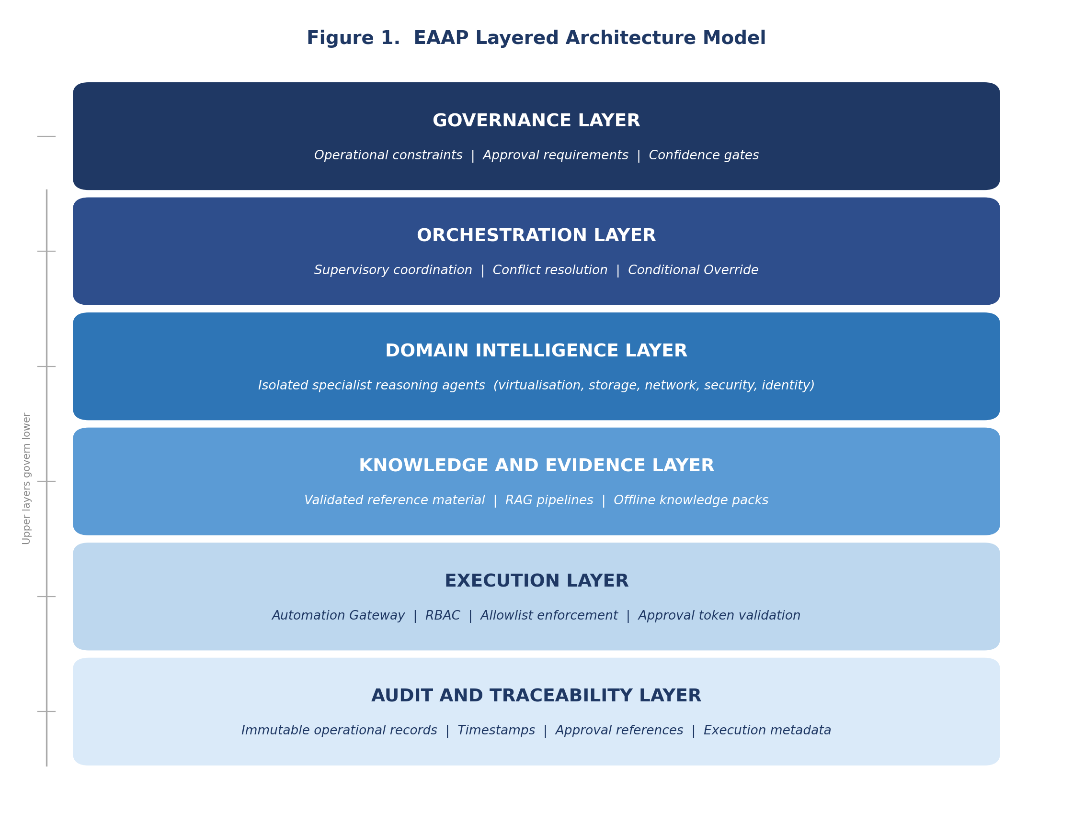
Figure 1 - EAAP layered architecture model.
Upper layers govern lower layers. The Execution Layer interfaces exclusively with operational infrastructure through the Automation Gateway.

6.2 Domain Isolation
Domain agents are isolated reasoning units. Each agent reasons only within its own domain, consumes domain-appropriate evidence, and cannot directly alter another domain's conclusions. Cross-domain interaction occurs only through the orchestration layer. This prevents domain contamination, cascading reasoning failures, and uncontrolled assumption propagation, directly addressing the domain contamination threat in Section 4.

6.3 Governance-Deterministic Orchestration
EAAP orchestration follows a structured lifecycle. Each phase is mandatory and sequenced. Figure 2 presents the orchestration lifecycle.

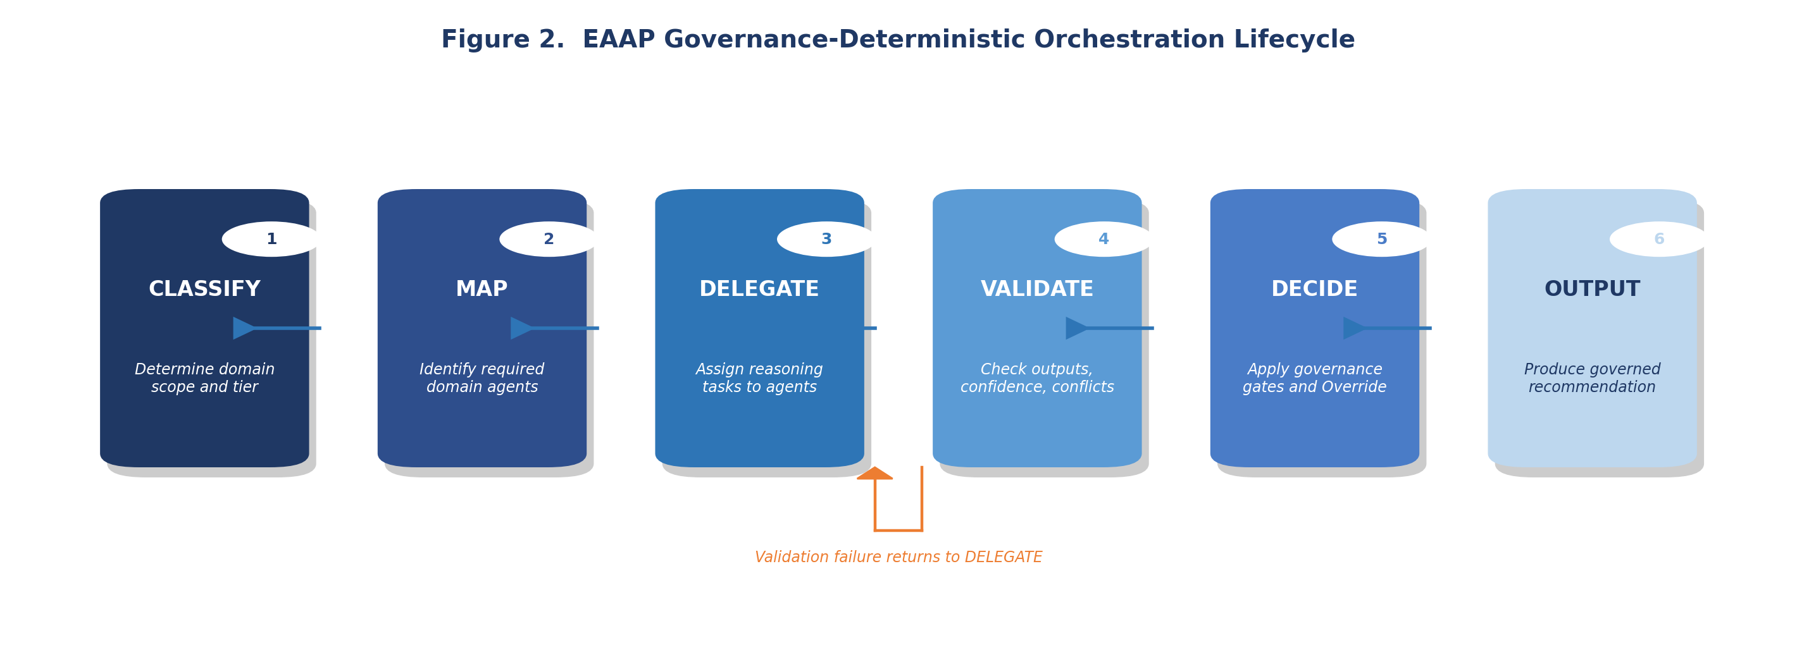
Figure 2 - EAAP orchestration lifecycle.
Each phase must complete before the next begins. Validation failure returns to DELEGATE.
The orchestration layer identifies required domains, delegates reasoning tasks, validates outputs, detects conflicts, and synthesises final recommendations. It does not replace domain reasoning. It governs it.

7. The Governance Layer

7.1 Evidence Classification
All EAAP outputs are classified using five evidence categories. Classification is mandatory and cannot be omitted. Table 6 defines the evidence classes. This directly addresses the hallucinated recommendations and evidence poisoning threats identified in Section 4.

Evidence Class | Description
Vendor-Supported | Official vendor documentation, validated architectures, or vendor-published guidance
Framework-Supported | Recognised industry standards or governance frameworks (ISO, NIST, BSI)
Best Practice | Industry-accepted operational guidance without formal standardisation
Heuristic | Expert operational reasoning based on practitioner experience
Assumption | Explicitly unverified premise that must be flagged and requires operator validation before execution
Table 6. EAAP evidence classification model.

7.2 Confidence and Uncertainty
EAAP treats uncertainty as operationally significant, consistent with the interpretability requirements established by Doshi-Velez and Kim [16]. Every recommendation must disclose known unknowns, expose uncertainty explicitly, and identify confidence limitations. Where confidence falls below required thresholds, recommendations are blocked, escalated, or routed for additional validation through the Conditional Override model.

7.3 Human Approval Boundaries
Human approval is structurally enforced. High-impact operational actions require explicit approval, change references, approval expiry windows, and auditable authorisation chains. Table 7 defines the four operational tiers.

Tier | Classification | Example | Approval Requirement
Tier 0 | Read-only | Status queries, reporting | None required
Tier 1 | Low-risk reversible | Non-disruptive configuration reads | Governance layer validation
Tier 2 | Disruptive operational | VM migrations, storage reconfigurations | Mandatory human approval
Tier 3 | High-impact or destructive | Data deletion, security policy changes | Mandatory human approval with change record
Table 7. EAAP operational action tier model.

8. The Orchestration Layer

8.1 Supervisory Coordination
The orchestration layer acts as a supervisory governance engine. Responsibilities include domain selection, orchestration sequencing, dependency awareness, confidence aggregation, and governance enforcement. It is the only component permitted to merge reasoning outputs from multiple domains.

8.2 Conflict Resolution
When domain outputs conflict, the orchestration layer identifies contradictions, evaluates evidence quality, and determines whether sufficient confidence exists to continue. Unresolved conflicts trigger escalation. All detected conflicts must be surfaced in the output regardless of whether resolution is achieved. Hidden conflict suppression is prohibited by GR-008, directly addressing the orchestration deadlock threat.

8.3 Conditional Override Logic
Conditional Override is triggered when confidence is insufficient, evidence is incomplete, governance requirements are unmet, or domain conflicts remain unresolved. The system does not produce authoritative recommendations in these cases. It exposes missing inputs and escalates for human review. This mechanism prevents false certainty, addressing automation bias risk documented by Parasuraman and Manzey [4] and Cummings [8].

9. The Domain Intelligence Layer
Domain agents operate as specialist reasoning systems. Each agent has bounded operational scope, consumes domain-specific knowledge, follows structured output schemas, and cannot autonomously execute operational changes. Grounding is provided by the Knowledge and Evidence Layer through RAG pipelines [11], allowing agents to retrieve validated reference material before generating outputs rather than relying on model weights alone.
Examples of domain agents include virtualisation agents (VMware vSphere, Nutanix AHV), storage governance agents, cybersecurity analysis agents, compliance review agents (ISO 27001, BSI IT-Grundschutz, EU AI Act), network configuration agents, and identity management agents. These examples are illustrative. EAAP does not prescribe specific vendors or platforms for any domain agent role.
The infrastructure examples used throughout this paper are illustrative and do not limit EAAP applicability to infrastructure operations or operational technology environments.

10. The Execution Layer

10.1 Automation Gateway Model
EAAP prohibits direct AI access to operational infrastructure. All operational interaction occurs through an Automation Gateway. The gateway exposes controlled API surfaces, implements RBAC, enforces allowlists, validates approvals, and records audit data. The AI system never directly executes infrastructure actions. This implements a hard execution boundary addressing the execution boundary bypass threat and consistent with NIST Zero Trust Architecture principles [13].

10.2 Plan-Approve-Execute Workflow
Operational execution follows a four-stage workflow. Figure 3 presents the workflow model.

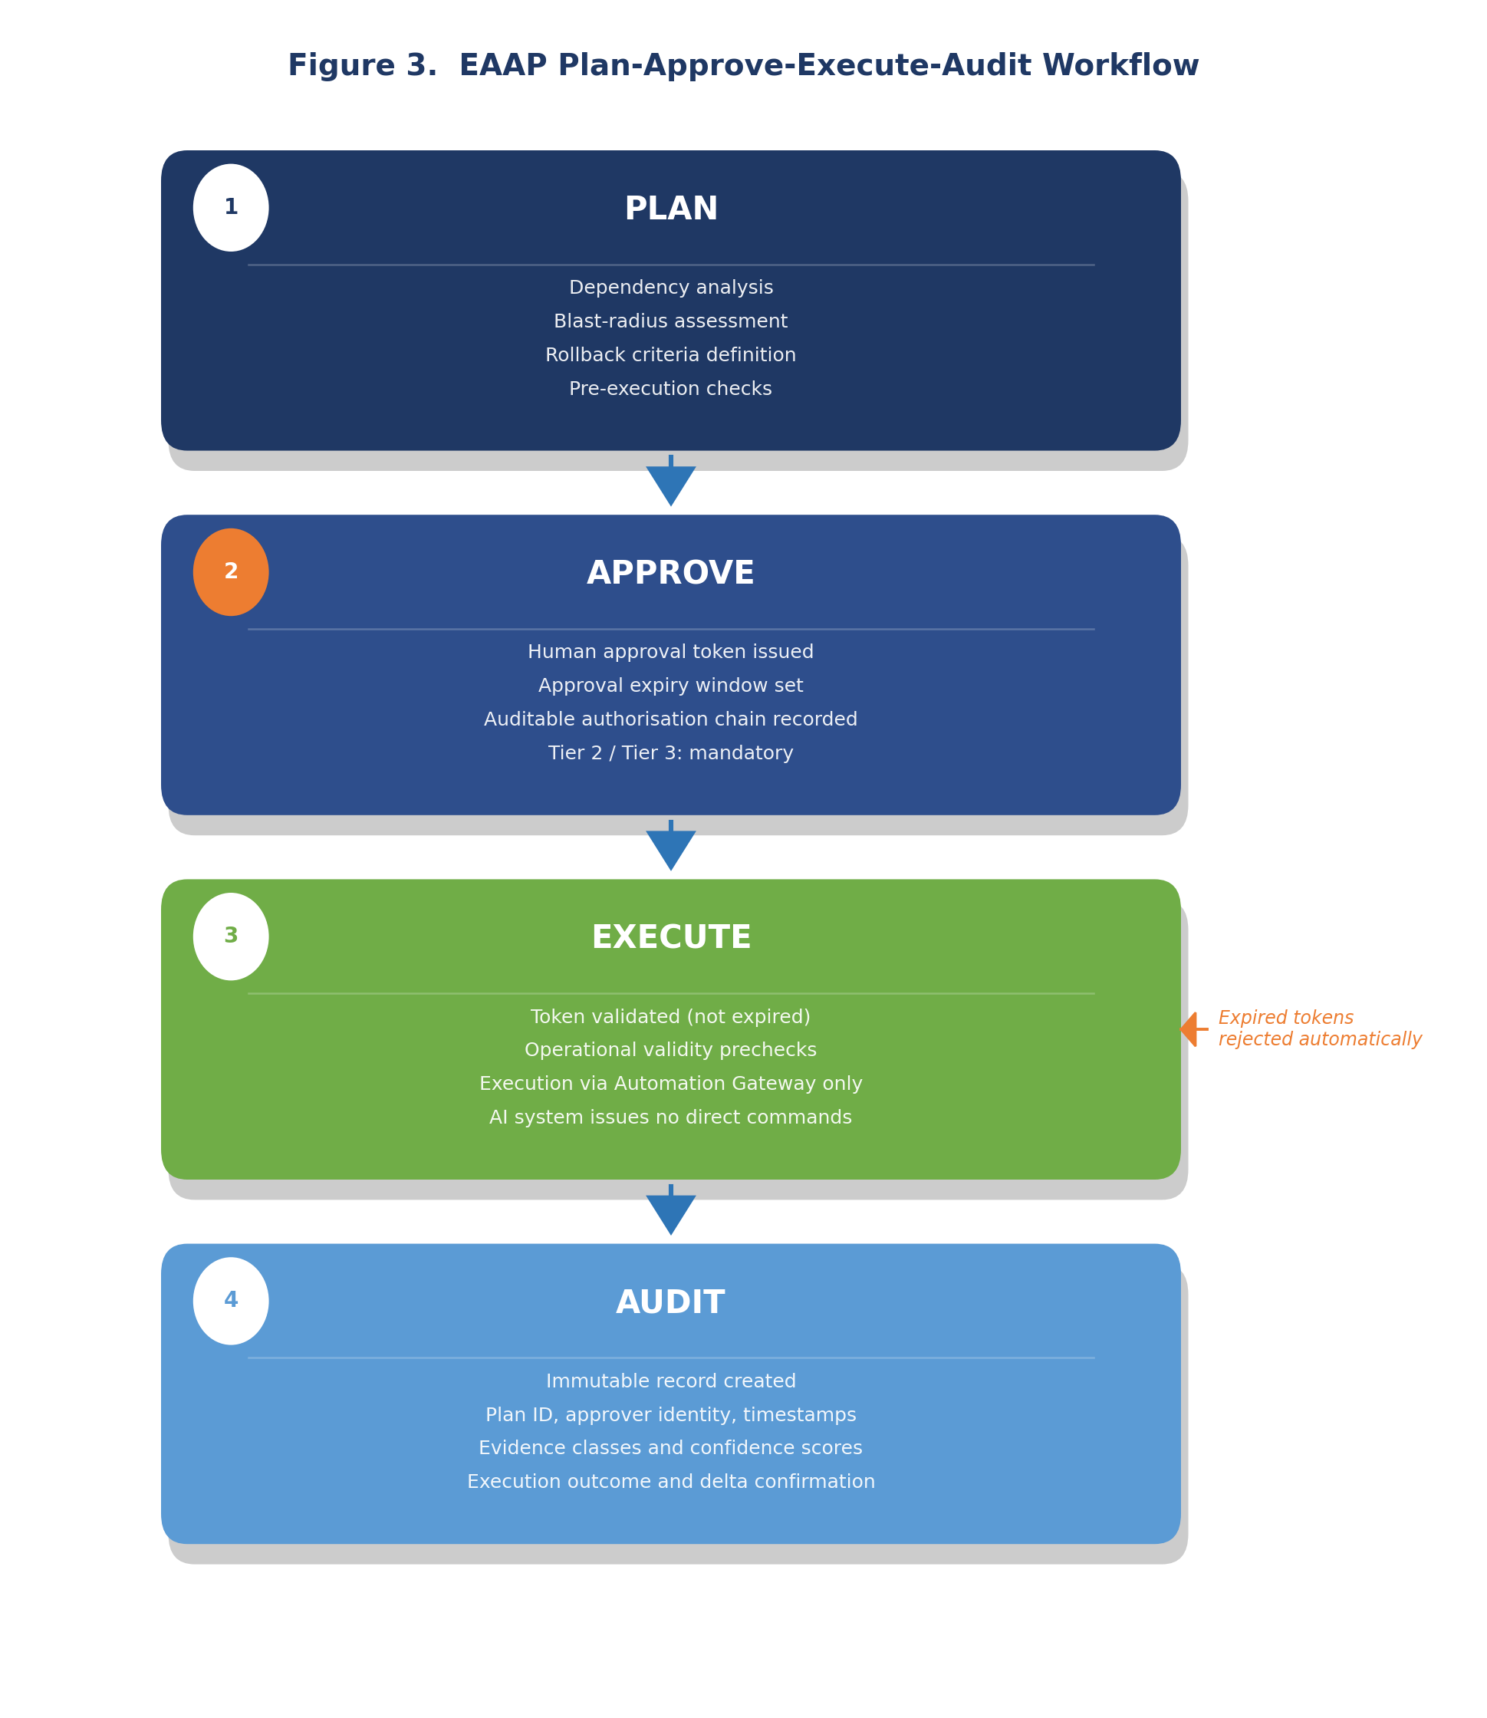
Figure 3 -EAAP Plan-Approve-Execute-Audit workflow.
Expired or invalid approval tokens are rejected automatically at the Execution stage.

The planning stage includes dependency analysis, blast-radius assessment, rollback criteria, and prechecks. Execution requires valid approval tokens and operational validity checks. Expired or invalid approvals are rejected automatically, directly addressing the stale approvals threat.

11. Air-Gapped and Sovereign Deployment
EAAP is designed to support sovereign and air-gapped deployment models. The framework assumes environments where external APIs may be prohibited, Internet connectivity may not exist, and operational data sovereignty is mandatory. This includes defence environments, regulated industries, critical infrastructure, and national-security-adjacent operations.
The framework supports local model inference using open-weight models, local vector storage for RAG pipelines, locally hosted orchestration, and offline knowledge packs. All EAAP layers are designed to operate without external connectivity, reducing data exfiltration risk and external dependency exposure.

12. Auditability and Traceability
EAAP requires operational traceability across recommendations, approvals, evidence references, orchestration decisions, and execution outcomes. Audit records include timestamps, user identity, plan identifiers, approval references, confidence classifications, evidence classes used, and execution metadata.
The framework assumes immutable audit retention for operationally significant actions, consistent with ISO/IEC 42001:2023 [3] and the NIST AI RMF [2] accountability requirements. Audit records must be retained in a tamper-evident form accessible to governance reviewers independently of the AI system that produced them.

13. Illustrative Scenario

13.1 Scenario Overview
The following scenario demonstrates how EAAP governs a realistic Tier 2 operational action in a Nutanix AHV enterprise environment. An operator submits a request to migrate 24 virtual machines from a source cluster to a target cluster during a scheduled maintenance window. The migration involves storage reconfiguration and network path changes affecting production workloads.

13.2 Governance Lifecycle Trace
Step 1: Request Classification (Orchestration Layer)
The orchestration layer classifies the request as a multi-domain operational change affecting storage, network, and compute domains. Tier assignment: Tier 2 (disruptive operational action). Required domains: virtualisation, storage, networking.
Step 2: Domain Reasoning (Domain Intelligence Layer)
Three domain agents are invoked in parallel. Virtualisation agent: Vendor-Supported evidence (Nutanix AHV live migration documentation). Storage agent: Vendor-Supported for capacity checks, Assumption for target performance under concurrent load. Networking agent: Best Practice (no explicit vendor guidance for this topology).
Step 3: Confidence Assessment (Governance Layer)
Combined confidence: 74 percent. Tier 2 threshold: 85 percent. Conditional Override invoked. The storage Assumption is unvalidated and the networking evidence is below the Vendor-Supported threshold required for Tier 2 actions.
Step 4: Escalation (Conditional Override)
The system surfaces the confidence shortfall, identifies the specific missing evidence, blocks the execution pathway, and routes the case to the operator for additional input. No authoritative recommendation is produced.
Step 5: Evidence Supplementation
The operator provides storage performance benchmarks and a confirmed network topology diagram. Revised combined confidence: 91 percent. Conditional Override is cleared.
Step 6: Human Approval (Governance Layer)
Tier 2 mandatory approval workflow triggered. An approval request is issued with the plan identifier, evidence summary, blast-radius assessment, and rollback criteria. The approver issues an approval token with a 4-hour expiry window.
Step 7: Execution (Automation Gateway)
The approval token is validated. Prechecks confirm host capacity, replication status, and network availability. Execution proceeds through the Automation Gateway. The AI system issues no direct infrastructure commands.
Step 8: Audit Record
An immutable audit record is created containing the request identifier, timestamps, operator identity, domain outputs with evidence classes, confidence scores, Conditional Override event log, approval reference, and execution outcome.

13.3 Scenario Observations
Three core EAAP behaviours are demonstrated. First, the system identified its own confidence shortfall without producing a false-certainty recommendation: governance failure was surfaced, not suppressed. Second, human approval was structurally required, not advisory: the execution pathway was blocked until a valid approval token was issued. Third, the large language model served as a reasoning component within a governed pipeline and did not exercise operational authority at any stage.

Step | Layer | Governance Action
1. Classification | Orchestration | Tier 2 assigned; domains identified
2. Domain reasoning | Domain Intelligence | Parallel reasoning; evidence classified
3. Confidence assessment | Governance | 74% < 85% threshold; Conditional Override triggered
4. Escalation | Orchestration | Missing evidence surfaced; execution blocked
5. Evidence supplementation | Governance | Revised confidence 91%; Override cleared
6. Human approval | Governance | Approval token issued with expiry window
7. Execution | Execution | Token validated; Automation Gateway executes
8. Audit | Audit and Traceability | Immutable record created
Table 8. EAAP governance lifecycle trace for the illustrative Tier 2 scenario.

14. What EAAP Cannot Do and Non-Goals

14.1 What EAAP Cannot Do
EAAP is intended to constrain AI systems, not grant them autonomous authority. Table 9 defines the framework limitations.

Limitation | Explanation
Cannot guarantee correctness | AI recommendations remain probabilistic regardless of governance controls
Cannot eliminate human error | Humans remain operationally responsible; EAAP cannot prevent approver error
Cannot resolve incomplete evidence | Missing evidence remains a governance problem; EAAP surfaces but cannot fill gaps
Cannot fully prevent automation bias | Operators may still over-trust AI outputs despite disclosure mechanisms [4][8]
Cannot replace enterprise governance | Organisational governance, policy, and compliance remain separately necessary
Cannot remove operational risk | Governance reduces but does not eliminate risk
Cannot make autonomous execution safe | Execution boundaries are mandatory and cannot be compensated by other controls
Table 9. EAAP framework limitations.

14.2 Non-Goals
The following items are explicit non-goals of EAAP. They are stated to prevent category errors in architectural interpretation and to reduce misdirected criticism.
EAAP is not:
- An AGI framework or general autonomous reasoning system. The framework is explicitly designed to constrain, not enable, AI autonomy.
- An autonomous execution framework. Human approval remains mandatory for Tier 2 and Tier 3 actions. The framework does not provide a pathway for unattended operational execution.
- A guarantee of operational correctness. EAAP governs the process by which AI recommendations are generated and authorised; it does not guarantee that those recommendations are correct.
- A replacement for enterprise governance, compliance, or risk management functions. EAAP supplements these functions architecturally; it does not supersede them.
- A model alignment framework. EAAP does not specify training methodology, reward functions, or model-level safety techniques. It operates above the model layer.
- A substitute for human accountability and professional responsibility. GR-007 is explicit: AI systems advise, humans decide, gateways execute.
- A vendor-specific product, platform, or software implementation. EAAP is an architectural control pattern. No specific vendor, framework, or model is mandated.

15. Governing Rules
EAAP defines ten governing rules. These are non-negotiable architectural requirements, not implementation recommendations. Table 10 enumerates all rules.

Rule ID | Governing Rule
GR-001 | Governance controls are structural and mandatory
GR-002 | Domain agents operate only within assigned scope
GR-003 | Evidence classification is mandatory for all recommendations
GR-004 | Human approval is mandatory for Tier 2 and Tier 3 actions
GR-005 | Known unknowns must be disclosed explicitly in all outputs
GR-006 | Execution requires a validated, non-expired approval token
GR-007 | AI systems advise; humans decide; gateways execute
GR-008 | Unresolved domain conflicts trigger escalation, not suppression
GR-009 | Auditability and traceability are mandatory for all significant actions
GR-010 | Governance requirements cannot be bypassed through prompt manipulation
Table 10. EAAP governing rules.

16. Current Limitations
This section identifies acknowledged limitations of the EAAP framework in its current form. These are not future research goals but present constraints that bound the claims made in this paper.

Limitation | Description
No empirical validation | EAAP has not been evaluated in a controlled enterprise deployment. All claims are based on architectural reasoning, not measured outcomes.
Confidence thresholds undefined | The framework defines a confidence gate mechanism but does not specify how threshold values should be calibrated for different domain types or action tiers.
Orchestration conflict resolution | The protocol for resolving multi-domain conflicts is defined at the principle level only. No formal arbitration algorithm is specified.
Automation bias not fully addressed | Evidence disclosure reduces but does not eliminate automation bias. Human factors research is required to quantify the residual risk.
Audit schema undefined | The framework requires immutable audit records but does not define a standardised schema, retention policy, or interchange format.
Air-gapped model lifecycle | Secure update, validation, and rollback pipelines for models in isolated environments are outside the current scope of EAAP.
Table 11. Current EAAP framework limitations.

17. Future Research Directions
This section identifies research directions that would extend, validate, or formalise EAAP beyond its current scope. These are open problems, not acknowledged deficiencies of the current framework.

Research Direction | Description
Empirical validation | Controlled evaluation of EAAP governance outcomes across multiple enterprise deployment environments and domain types
Formal specification | Mathematical formalisation of governance determinism per the approach of Seshia et al. [18], enabling proof-based assurance of governance lifecycle correctness
Confidence calibration methodology | Development of a principled method for setting and validating confidence thresholds across domain types, evidence classes, and action tiers
Human factors research | Empirical studies of automation bias in EAAP-governed environments to quantify the residual risk of over-trust despite evidence disclosure
Governance interoperability | Integration of EAAP governance records with enterprise ITSM, SIEM, and CMDB tooling through standardised interchange formats
Cross-domain reasoning assurance | Formal assurance methods for orchestration correctness in adversarial scenarios, including evidence poisoning and prompt manipulation
EAAP standardisation | Engagement with standards bodies (ISO/IEC JTC 1/SC 42, NIST) to assess alignment and potential standardisation of EAAP governance principles
Table 12. Future research directions for EAAP development and formalisation.
EAAP is intended to evolve through future publications as empirical evidence, formal analysis, and implementation experience accumulate. The author invites technical collaboration from enterprise architects, AI governance researchers, operational engineering teams, and standards communities.

18. Conclusion
Enterprise AI systems increasingly operate in environments where operational trust, auditability, governance, and controlled execution matter more than raw model capability. This paper has argued that the primary challenge in enterprise AI is architectural rather than purely algorithmic.
EAAP proposes a governance-oriented architecture pattern that structures AI reasoning, constrains operational execution, isolates domain intelligence, exposes uncertainty, enforces human approval, and maintains operational auditability. The framework positions the large language model as a replaceable reasoning component within a larger governed system. A formal threat model defines nine failure modes the architecture is designed to address.
The framework is implementation-neutral: EAAP defines governance principles independent of specific vendors, models, or orchestration platforms. Governance determinism, as defined in this paper, is an architectural property of the system as a whole, not a property of any individual component.
Current limitations are acknowledged. Empirical validation, confidence calibration, and formal specification remain open research areas. The governance gap in enterprise AI is real and growing. Addressing it requires architectural commitment, not merely policy intent.

Central Principle
AI systems may assist operational reasoning, but governance authority, accountability, and execution responsibility remain structurally human.

Appendix A: Terminology
This appendix defines the primary architectural terms introduced or given specific meaning within the EAAP framework. These definitions are binding for the purposes of interpreting this paper and any subsequent EAAP publications.

Term | Definition
Governance Determinism | A new architectural term introduced by this paper. An AI system is governance-deterministic if its governance conditions are defined in advance, uniformly applied, and structurally enforced, independent of model output variation. Distinct from computational determinism in formal methods.
Conditional Override | A governance mechanism triggered when confidence is insufficient, evidence is incomplete, or domain conflicts are unresolved. Prevents false-certainty recommendations by blocking the execution pathway and escalating to human review.
Domain Isolation | The architectural principle that each domain agent reasons only within its assigned technical domain. Cross-domain interaction is mediated exclusively by the orchestration layer. Prevents domain contamination and assumption propagation.
Confidence Gate | A governance control that compares aggregated domain confidence against a pre-defined tier threshold. Recommendations that do not meet the threshold trigger Conditional Override rather than proceeding to the approval stage.
Evidence Classification | The mandatory assignment of an evidence class (Vendor-Supported, Framework-Supported, Best Practice, Heuristic, or Assumption) to all AI outputs, disclosing the provenance and reliability basis of each recommendation.
Sovereign AI | AI system deployment in which all components, including model inference, knowledge storage, and orchestration, operate within a defined data sovereignty boundary without external network dependencies. Applicable to air-gapped and regulated environments.
Execution Isolation | The architectural requirement that AI systems interact with operational infrastructure only through the Automation Gateway. Direct execution by the AI system or its intermediary components is prohibited.
Automation Gateway | The sole authorised interface between the EAAP execution layer and operational infrastructure. Implements RBAC, allowlist enforcement, approval token validation, and execution audit logging.
Table A1. EAAP terminology definitions.

References
[1] Floridi, L. et al. (2018). AI4People - An Ethical Framework for a Good AI Society. Minds and Machines, 28(4), 689-707. https://www.research-collection.ethz.ch/server/api/core/bitstreams/47a754b6-979f-46c6-9c98-9485e8ffdcb1/content
[2] NIST. (2023). Artificial Intelligence Risk Management Framework (AI RMF 1.0). National Institute of Standards and Technology. https://www.nist.gov/itl/ai-risk-management-framework
[3] ISO/IEC 42001:2023. Artificial Intelligence Management Systems. https://www.iso.org/standard/81230.html
[4] Parasuraman, R., & Manzey, D. H. (2010). Complacency and Bias in Human Use of Automation. Human Factors, 52(3), 381-410. https://www.researchgate.net/publication/47792928_Complacency_and_Bias_in_Human_Use_of_Automation_An_Attentional_Integration
[5] United Nations. (2023). Governing AI for Humanity. Advisory Body on Artificial Intelligence. https://digitallibrary.un.org/record/4062495?v=pdf
[6] European Union. (2024). EU Artificial Intelligence Act. https://eur-lex.europa.eu/eli/reg/2024/1689/oj
[7] Scharre, P. (2018). Army of None: Autonomous Weapons and the Future of War. W.W. Norton & Company. https://www.jstor.org/stable/pdf/26891891.pdf
[8] Cummings, M. L. (2004). Automation Bias in Intelligent Time Critical Decision Support Systems. AIAA Intelligent Systems Technical Conference. https://arc.aiaa.org/doi/10.2514/6.2004-6313

Acknowledgements
The author acknowledges the broader enterprise architecture, AI governance, and operational engineering communities whose ongoing discussions around auditability, controlled execution, sovereign infrastructure, and human oversight have informed the development of EAAP.
This paper is a conceptual governance architecture proposal. It has not undergone formal peer review. The author welcomes technical discussion and critical review from enterprise architects, AI governance researchers, operational engineering teams, and standards communities.

